**4CS Rental Gap Analysis Report**

**Transactions:**

1. Purchase Order - MIF Link added on PO after IR creation. Currently not available in 4CS

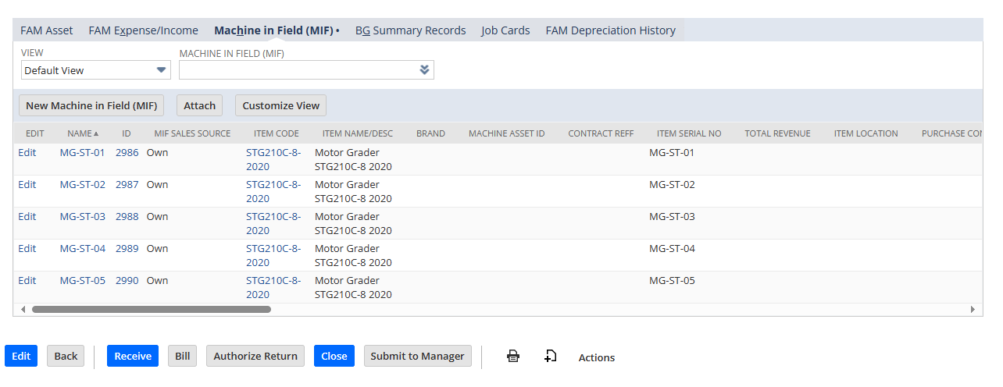

1. Item Receipt – MIF records link on IR. Currently not available in 4CS

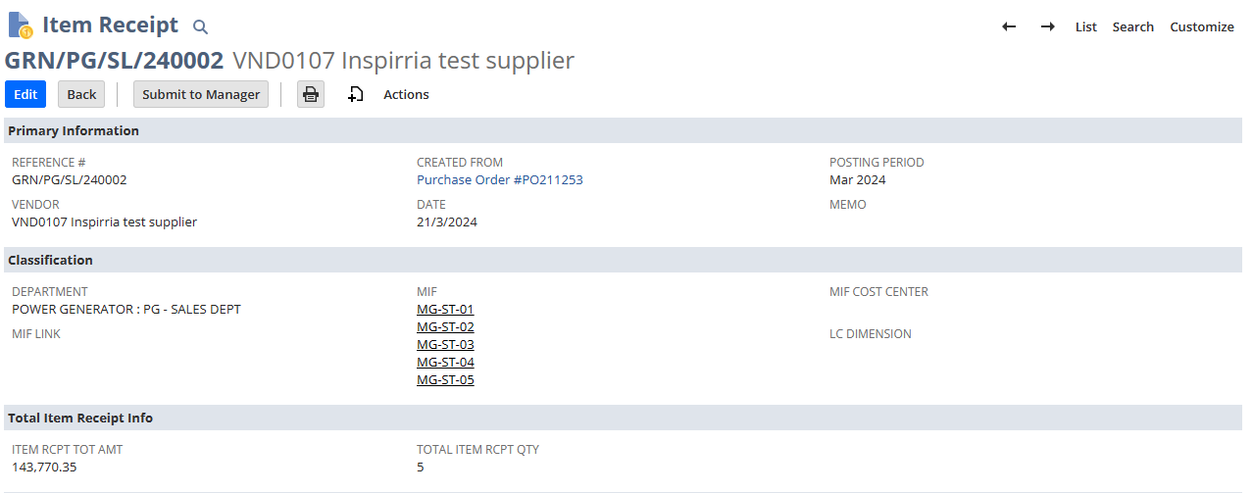

1. IN MIF related records IR transaction updated – Currently not available in 4CS

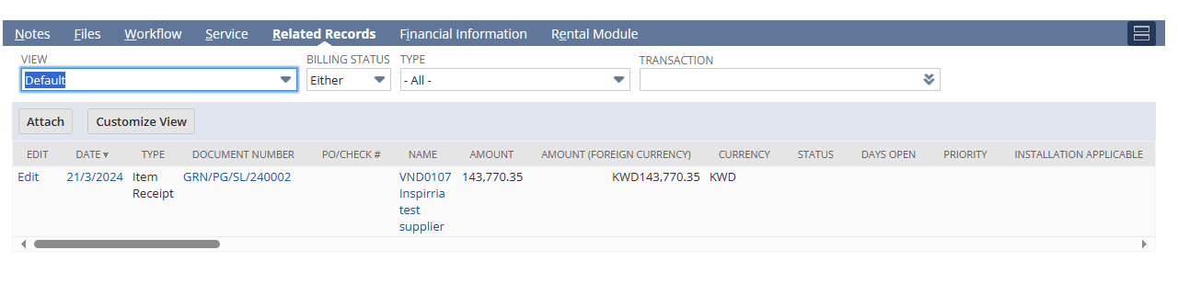

1. Sales Order – Machine rate per date and other rates automatically updated on SO from rate entered. Currently not available in 4CS

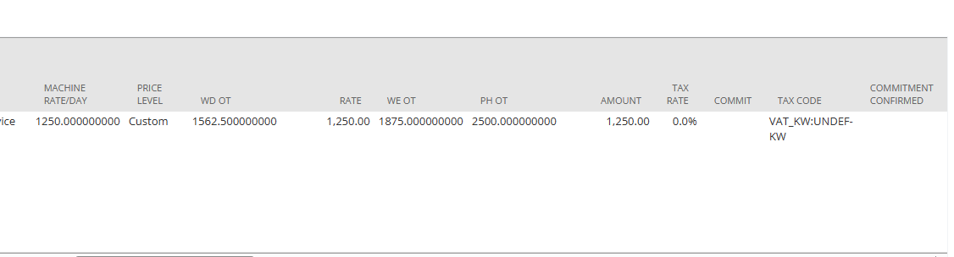

1. MIF record to be selected on SO and only 1 MIF can be selected. Currently not available in 4CS

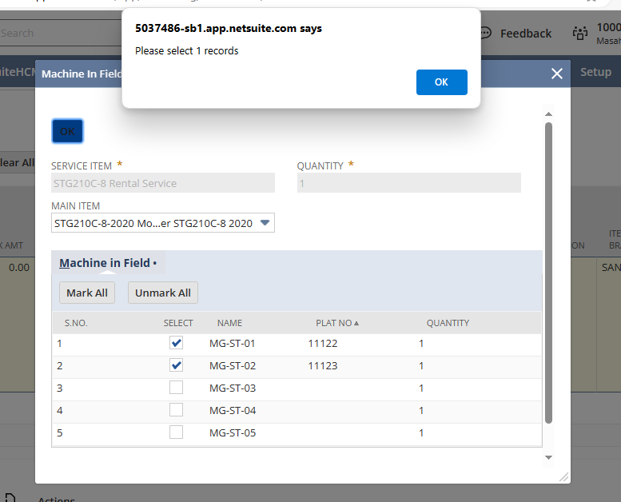

Suietlet does not updates related records & On IF MIF box already checked

1. Post IF Creation – Related records updated, on SO is rental box checked & related records also showing on SO.
2. Rental Contract Creation - UOM Available on RC. To be used in time entries.

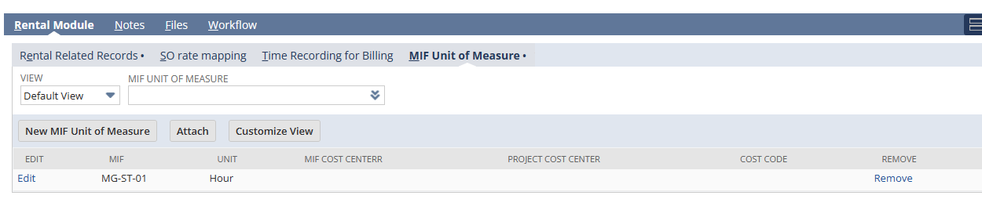

1. Time Entries - Data fetched from customer and rental contract.

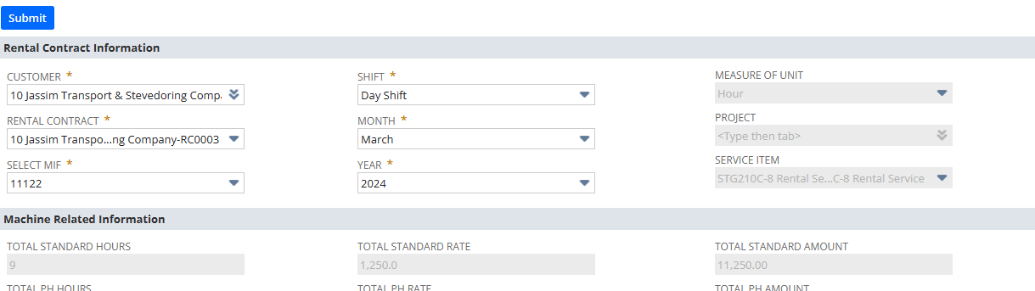

1. Invoicing – Time entries available on invoice.

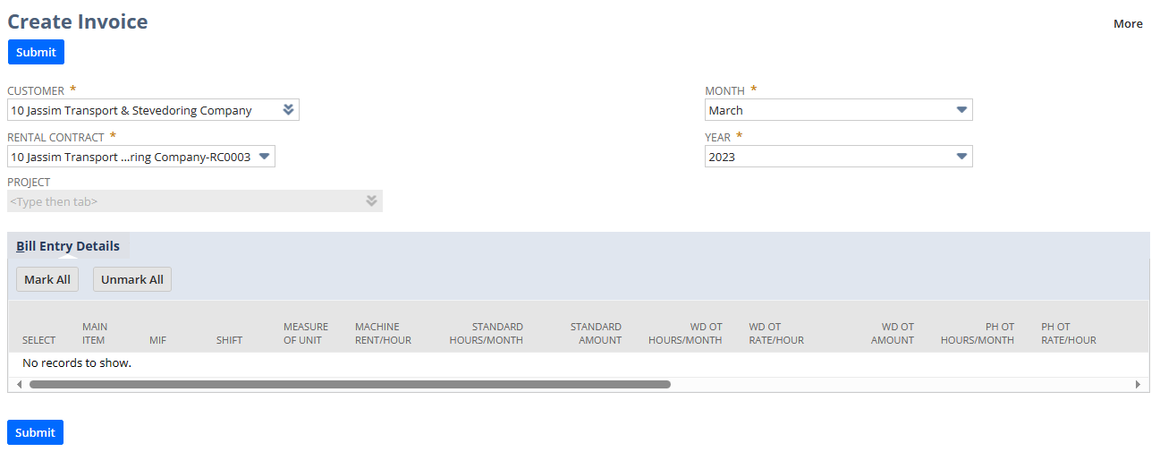

1. Billing Status record available on Rental contract.

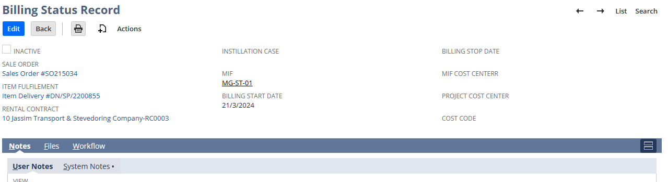

1. Time Entry and Invoicing -

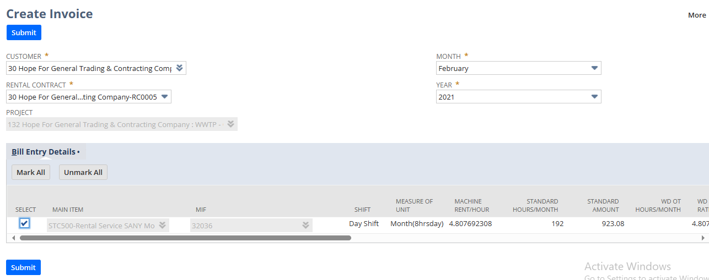

Time entries on rental contract

